IBM ASSIGNMENT 2

Reg No:1919103048

Name:Kanishka Karthikeyan

**CODE**:

import random import time while(1!=0):

temperature = random.random() humidity = random.random() print("temperature: ", temperature) print("humidity: ",humidity) time.sleep(2)

if (temperature > 0.5): print("high temperature")

if ( humidity >0.5): print("high humidity")

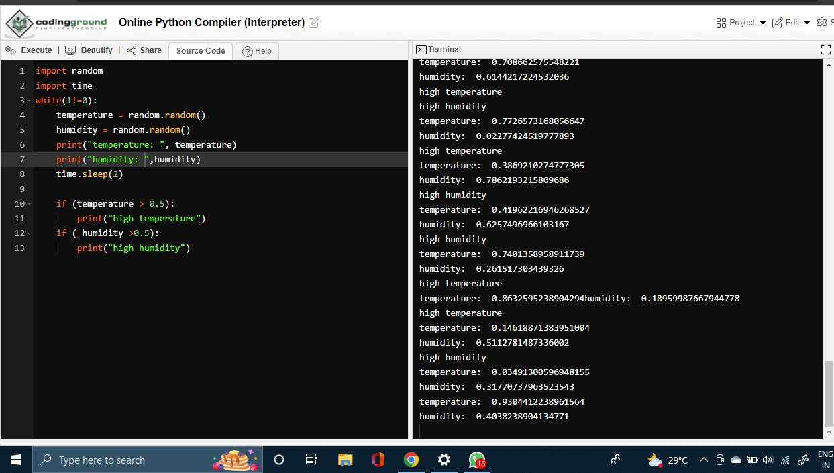**Simulations**: